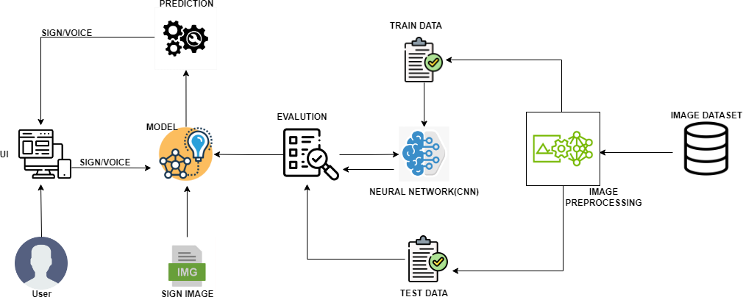

|  |  |
| --- | --- |
| **Date** | 27 October 2022 |
| **Team ID** | PNT2022TMID23730 |
| **Project Name** | Real-Time Communication System Powered by AI for Specially Abled |

**Technical Architecture:**

Project Design Phase-II

Technology Architecture